This is a readme file to explain the training sample set and simple viewers that are used in the following publication.

Huijing Zhao, Yiming Liu, Xiaolong Zhu,Yipu Zhao, Hongbin Zha, Scene Understanding in a Large Dynamic Environment through a Laser-based Sensing, IEEE Int. Conf. on Robotics and Automation (ICRA), 2010.

If you use the data or viewer, you are obligated to cite our research in your report.

For any question, please contact: zhaohj@cis.pku.edu.cn

[Data Sets]

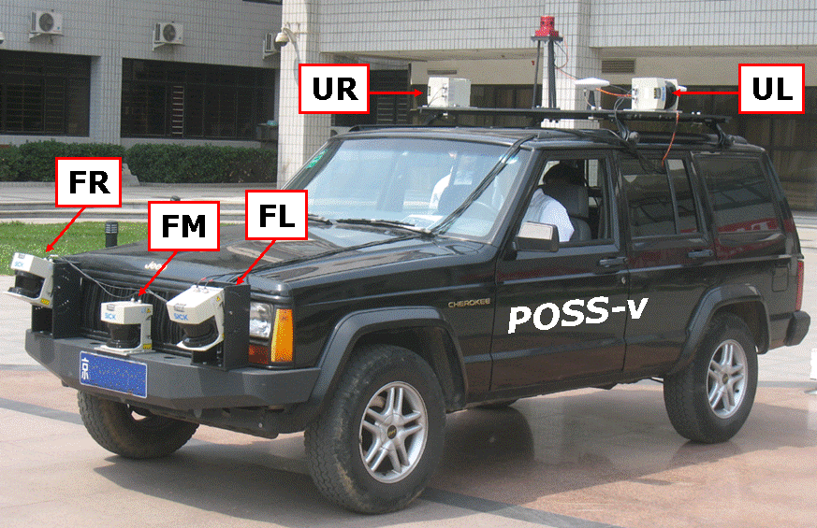

LMS291@SICKs are used to acquire laser data as the vehicle moves along street. The data from each laser scanner can be represented in range image, and can be converted into 3D points. The training data samples are extracted from either UR or UL, and are represented in both forms. They are explained below in details.

- RI
The folder “ri” contains the training data samples in the representation of range image. It has two sub-folders, i.e. “UR” and “UL”, containing the data corresponding to each individual sensor. In each sub-folder, there are different types of data that are explained below.

- *.region and *.seg
The *.region and *.seg file pair is a set of training sample data. *.seg contains the laser points in each labeled region (i.e. segment); *.region is basically a bitmap, corresponding to the range image, pixel value is region id that the pixel belongs to.

Training sample data are named as follows.
e.g.
building-super: the training samples of building on super segmented data
building: the training samples of building on contour segger
merge: a sample data contains all kinds of objects excepts tree
merge-with-tree: a sample data contains all kinds of objects including tree
merge-super: a merged sample data without tree on super segments
merge-with-tree: a merged sample data of all kinds on contour segger

- *.ds, *.calib, *.mdl

These data are not training samples. They are mainly used in the viewers to show the training data samples. In order to use the data, you need to change the DIR setting at the *.mdl file to the directory of your *.ds2 and *.calib files.

DIR C:\DsData\ul\ //change to the folder where you copied the data
DS a20090413132336.ds2
CALIB ul.calib

- 3DPTS

Each *.pt3d is a binary file contains the laser points from one laser scanner.
ur represents the laser scanner of upper-right laser scanner (vertical scanning)
ul represents the laser scanner of upper-left laser scanner (vertical scanning)

*.pt3d contains a sequence of point3d, the structure of which is defined as follows.
typedef struct {
double x, y, z;
BYTE r, g, b; //synthesized color representing object class
} point3d;

[*.nav Format]
*.nav is an ascii file contains the vehicle pose in local coordinate system. Each row records the following data.

time gtrans.ang.x ang.y ang.z shv.x shv.y shv.z

[Viewer]

- RangeSeg.exe

View the training samples in the form of range image（*.region and *.seg）, and the data can be converted into *.pt3d.

Usage:
- Start RangeSeg.exe
- File->LoadMDL，select the *.mdl file
- File<-RegionSeg，load a set of *.region and *.seg file pair
- According to requirement, you can load a number of training data sets by using
File<-AddRegionSeg
- According to requirement, you can also merge with a number of training data sets by
File->RegionSeg
- File ->RgbPt Classi，output the training data samples into *.pt3d format. Color represent for class

- dataviewer.exe

A view the 3D points.

Usage:

1. Start datviewer.exe
2. File->Load Points(BIN), load *.pt3d file, each for one file, you can load multiple files. The laser points of each load will be assigned to one layer no, the first load will be Layer 0, second load will be layer 1, etc..
3. File->Load Nav Data, load *.nav file.
4. Setting->LayerInfo, set layer color, point size and display or no. E.g. select one layer, check Color by Layer, set Color to "0,255,0", push Update, then the points in that layer will be shown in Green.
#You must push Update so that to update layer info, and if you want to assign color to a certain layer, you must check Color-by-Layer.
Finally close the dialogbox.
5. Setting->ViewSet, modify the viewdepth to select the points be viewed. e.g. viewdepth = 1000 (almost all laser points are viewed), viewdepth = 100 (the laser points far away are not drawn)
6. Option->Animation, press ESC to stop animation

You can change view points by press
Left/Right/Up/Down arrow key: shift eye position to left/right/forward/backward
PgUp, PgDn: shift eye position to up, down
Control/Shift+Left/Right arrow key: rotate heading
Control/Shift+Up/Down arrow key: rotate pitch angle
Control/Shift+PgUp/PgDown arrow key: rotate roll angle

